\*\*\*\*IMPORTANT\*\*\* SUBMIT MY CASE TO FTC FOR YOUR SUSPECTED FRAUD ON MY ORDER

Hi,

FIRST I PUT MY ORDER NUMBER HERE: 279109319. AND I NEED TO DECLEAR IN ADVANCE: THIS EMAIL MIGHT BE THE EVIDENCE AT COUNCIL IF NEEDED IN THE FUTURE.

I have no word to describe how you, IKEA, frustrate me by YOUR IREESPONSIBLE customer service, and the WAY how YOU TREAT YOUR CONSUTOMER. After I CALLED you THOUDSAND OF TIMES WITHOUT ANYONE ANSWERING and SENT you TONS OF EMAILS WITHOUT ANY REPLY, I finally decided to submit my case to Bureau of Consumer Protection of FTC. They will take the investigation. I did the same thing on Walmart when they really pissed me off by their irresponsibility, and the positive result leads me to fighting for a customer’s right that I should be treated fairly. Before doing this, I need to send you an email to explain the whole process.

I moved to my new apartment half a month ago. And I ordered the bed and sofa and all the things from IKEA, because I trusted you. And I also PAID for the express delivery because I need to move in ASAP. So the order should be received on 3/1/2018. And the scheduled delivery time was 3/3/2018. And then I received the email to show the order was canceled on 3/2/2018. I took the Uber to IKEA to make clear what happened because NO ONE ANSWER MY PHONE, which costed 50 USD. And I was told by the salesman there it was a mistake because of the chaos in the system. I said it was fine if they could just reschedule it and delivery it ASPS. And they PROMISSED me they would delivery it on 3/7/2018. And on 3/6/2018 I received a call from IKEA telling me the order would be late because of the extreme weather and I thought it was fine because it was not your problem, however I saw the weather was fine, and I received all the other packages from Fedex and USPS. I am not a mean guy. I forgave you. And I got the promise AGAIN it would be delivered on 3/10/2018. And guess what happened?????? I stayed at home for a whole day waiting for your delivery and I was told the delivery was canceled because there was no one at home??????? Then I tried to call you and guess what???? NO ONE ANSWER!!!!! I PAID 2,000 USD/ MONTH RENT and I AM LIVING IN THE HOTEL FOR HALF A MONTH!!!!!!!!!!!!!!!!!!!!!!!!!!!!!!!!!!!!!!!!!!!!!!!!!!!!!!!!!!!!!!!!!!!!!!!!!!!!!!!!!!!!!!!!!!!!!!!!!!!!!!!!!!!!!!!!!!!!!!!!!!!!!!!!!!!!!!!!!!!!!!!!!!!!!!!!!!!!!!!!!!!!!!!!!!!!!!!!!!!!!!!!!!!!!!!!!!!!!!!!!!!!!!!!!!!!!!!!!!!!!!!!!!!!!!!!!!!!!!!!!!!!!!!!!!!!!!!!!!!!!!!!!!!!!!!!!!!!!!!!!!!!!!!!!!!!!!!!!!!!!!!!!!!!!!!!!!!!!!!!!!!!!!!!!!!!!!!!!!!!!!!!!!!!!!!!!!!!!!!!!!!!!!!!!!!!!!!!!!

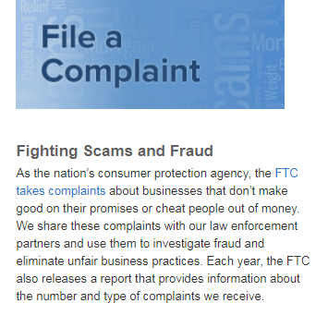

According to the FTC’s definition, you guys do not make good on your promises and cheated me 3 times IN A ROW.

REPLY me or give me a call ASAP or let us see in the council.

YOUR CUSTOMER